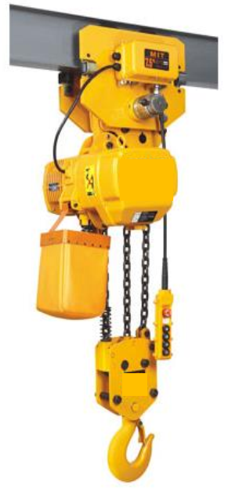
5 Ton electric chain hoist, 3 phase, 415V 50 HZ with installation and testing Functional Requirement
This is an H beam mounted electric chain hoist capable of safely lifting, transversing and lowering loads upto 5 tons. The hoist is operated by hand-controlled pendant. Power supply is 3 phase 415 VAC, 50 HZ The hoist crane assembly should have safety limit switches at both ends of each beam to provide safety mechanisms in the event the hoist carne overtravels. The hoist crane should be fitted with appropriate safety alarm that should be operated automatically during the operation of the hoist crane. The picture below shows the typical mounting position of the hoist crane for the purpose of aiding
the understanding of the requirement.
Disclaimer; The picture does not whatsoever give preference to a particular brand, construction or color of any hoist crane. It only serves to assist the bidders to understand the Client’s expectation of the required product and is only for the purpose of aiding the understanding of the product. Bidders are encouraged to propose their individual product design and construction offering of the electric hoist crane to the Client.

SPECIFICATION OF 5 MTON OVERHEAD CRANE - NAIROBI LOCOSHED
Item | Description | Specification
1 | Product | 5 Ton electric chain hoist, 3 phase, 415V  50 HZ
2 | Quantity | 1 No (ONE)
3 | Power Supply | 415 V AC, 3 PHASE, 50 Hz
4 | Lifting Load | Upto 5 MTON
5 | Lifting height | Up to 5 meters as determined by the height of the pre - existing H beam construction at the intended installation facility
6 | Span of movement | Upto 10 meters as determined by the length of the pre - existing H beam construction at the intended installation facility
7 | Operation type | Pendant Operated
8 | Warranty | Minimum 12 Months
9 | Lifting speed (Meters/ min) | 1.8
10 | Chain Falls | 3
11 | Max Lifting Motor power (KW) | 3
12 | Lifting Motor rotation speed (Rotation / Minute) | 1440
13 | Travelling motor Power (KW) | 0.75
14 | Travelling motor rotation  speed (Rotation/ Minute) | 1440
15 | Mounting beam | To be mounted on the pre- existing H  beam. Width of the beam is approximately  190 mm
16 | Installation, testing, commissioning and installation accessories | The Overhead electric hoist chain is to be mounted by the bidder, connected to power supply, tested and commissioned in totality without any additional cost to KR whatsoever on the appropriate location and place at the intended loco shed facility. All mounting and installation materials, tooling, consumables are to be supplied by the bidder at no additional cost  to KR.  Any structural modifications to strengthen the H beam so as to safely accommodate all the lifting operations is to be undertaken by the bidder with no extra cost to KR.  The bidder is expected to undertake all electrical installation including provision of the required materials and cabling to supply power to the electric hoist chain with no additional cost to KR
17 | Training | Operational and maintenance training to be provided
18 | Manuals and electrical drawings | To be provided by supplier. Must be printed in English language. Supplier to provide both soft copies and hard copies of the documentation. These documentations are maintenance  manuals, part catalog, electrical wiring and  schematic diagrams.
19 | Protection | All panels, limit switches and motors shall  have IP 54 protection.

