Customer: Date：2021-02-5

SPECIFICATION & Quotation
1、 AIR hoist
Model： ACH2004S
Unit Price： 50000USD
Capacity（SWL）： 20T
Lift Height： 12m
work pressure： 4-6 Bar
Chain type： Link Chain
Chain falls: 4 Hook type： with safety latch
Lift speed(no load)： 1.4 meters/min
Lift speed(full load)： 0.7meters/min
AIR consumption： 5.5m³/min
Air trolley
Track width range（H beam） 250-300mm
Traversing speed： 5m/min

Standard Features： Stepless speed regulation/simple and convenient operation/suitable for high temperature, humidity, dust, explosives, etc. Additional features: the above products have automatic overload protection (to prevent overload conditions), limit protection and air cut protection.

2、CONTROL
Price： Included
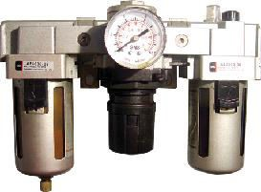Type： A type Push button Remote Hand Control
3、 AIR FILTRATION
Price： Included
Type： AC4000-04

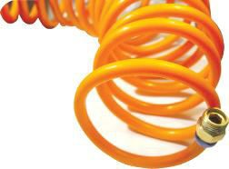4、 AIR PIPE（Spiral Pipe）
Price： Included
Type： Stretch length 9M

DOCUMENTATION Instructions. Instruction Manual (including installation, use, maintenance, lubrication parts list and exploded views).

