We’re visiting your website and we’re interested with you hydraulic cargo platform lift.

Herewith some detail for your reference.

Lift No. | LS-WAHD-01
Type | Hydraulic
Shaft Size (W x D) (mm) | 5000 x 7500
Overhead (mm)
Pit (mm)
Capacity (kg) | 10000
Speed (m/s)
Car Size (W x D x H) (mm) | 5500 x 4000 x 3500 (Ceiling Clear Height)
Door | Roller Shutter (Fire Rated)
Door Size (W x H) (mm) | 5500 x 3500
Travel (mm) | 18000
Floor Served | 2

You may propose the overhead and pit you require, as well as any other requirements.

Just for your information, this lift will be used to transport the bogie of a train between floors for maintenance. The train tracks are embedded inside of the ground (flush with FFL) and will be running all the way into the lift, please take this into account for your design as well.
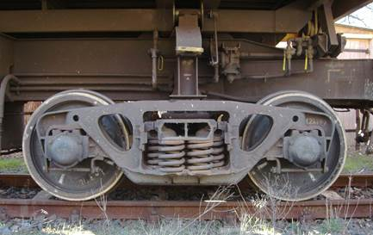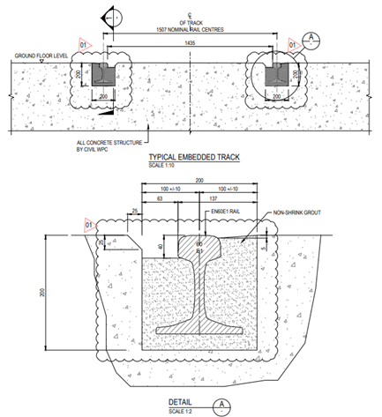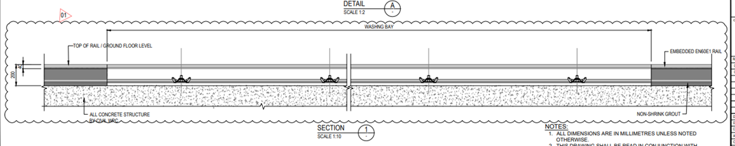

Kindly have a look for based on given information.

By the way, we would like to get more details from you regarding hydraulic cargo platform lift. It will be great if you can provide the technical catalogue for us.

