Инв. № подл. Подл и дата Взам. инв.№ Инв. №дубл. Подп. идата
Auxiliary winch
Initial technical requirements
54024.44.000 ITT
2019
CONTENT

1 PURPOSE AND SCOPE
  - Auxiliary winch, hereinafter referred to as a winch, is designed for transportation of goods and tools from the receiving bridges to the drilling site, as well as lifting various cargoes at the drilling site within the nominal load capacity.
  - The winch is designed for operation as part of a drilling rig in macroclimatic regions with a temperate climate, placement category U1 (from minus 45°С to plus 40°С) according to GOST 15150-69 in fields with a hydrogen sulfide content of less than 6%.
  - The winch is located in the explosive zone.
According to the requirements of the Technical Regulations of the Customs Union TR CU 012/2011 "On the safety of equipment for operation in explosive areas" (approved by the Decision of the Commission of the Customs Union No. 825 dated November 18, 2011):
- explosive zone class - 1 (V-1 g according to the PUE);
- explosive mixture category - II;
- explosive mixture group according to ignition temperature - TK.

Inv. no. |Signature and date Subm. Inv. No. Inv. duplicate number Mean, and date
 |  |  |  |  | 54024.44.000 ITT | Sheet
 |  |  |  |  |  | 3
Izm | Sheet | Document No. | Signed | date

Инв, № подл. |Подл и дата| Взам. инв.№ Инв. №дубл. Подл, и дата
 |  |  |  |  | 54024.44.000 ИТТ | Лист
 |  |  |  |  |  | 4
Изм | Лист | № докум. | Подл. | Дата

2 PARAMETERS AND TECHNICAL DATA
2.1 Technical characteristics are given in table 2.
Table 2 - Specification
Carrying capacity, t - 5
Electric motor:
Power, kW 15
Mode of operation (repeated-short-term) E4
Duty cycle (duty cycle) % 40
Rated speed, rpm 1470
Voltage, V 380
Rated frequency, Hz 50
Degree of explosion protection of the electric motor 1 ЕхbПТЗ
Rope tension, kN - 49.05
Drum diameter, mm - 250
Rope winding speed, m/s - 0.32
Adjustable ascent/descent speed over the entire range from 0 to 0.32 m/s
Braking torque of the brake, Nm -130
Weight, kg - 740
Overall dimensions, mm
length -1118
width _ 650
height -1 460
Recommended rope type
15.5 - G - VK - S - N - R - T - 1860 GOST 3079-80
Drum rope capacity, m 100
- DESIGN REQUIREMENTS
  - Description of main parts:
Инв. № подл. |Подп и дата Взам. инв.№ Инв. №дубл. Подп. и дата
The winch frame should be the main bearing part of the winch. It should be a welded metal structure, which has great strength and rigidity and is able to withstand deformation during operation and transportation. The frame must have special pull grips for slinging the winch. The frame must have space for attaching it to the frame of the auxiliary drilling rig winch module. The frame must be equipped with grounding bars for the frame itself and the electrical equipment installed on it. The layout of the mounting holes is shown in Figure 2.
The drum must be of welded construction. Holes for fastening the rope must be provided in the drum flange. The drum shaft must be mounted in bearings. Shaft bearing housings must have grease fittings to lubricate the bearings. The transfer of torque to the drum must be ensured by an inextricable kinematic connection. The use of friction joints, as well as friction and cam clutches, is excluded. The use of interference fits in connections that transmit torque is allowed if there is an additionally installed key. On the winch drum, cutting must be made for the correct laying of the rope on the drum.
The electric motor must be explosion-proof. The transmission of torque from the electric motor must be ensured by an inseparable kinematic connection. The use of friction, press and other similar connections, as well as friction and cam clutches is not allowed.
The electromagnetic brake is normally closed.
Braking and stopping of the drum is carried out by an electric motor from a frequency converter, followed by applying a brake.
Serves for fixing the drum after stopping, as well as braking in an emergency in case of failures in the electric motor control system.
The guard must provide protection for personnel from rotating parts when the winch is in operation. The winch guard must have an ergonomic shape and an aesthetic appearance.
 |  |  |  |  | 54024.44.000 ИТТ | Лист
 |  |  |  |  |  | 5
Изм | Лист | № докум. | Подп. | Дата

Инв. № подл. |Подп и дата Взам. инв.№ Инв. № дубл. Подл, и дата
 |  |  |  |  | 54024.44.000 ИТТ | Лист
 |  |  |  |  |  | 6
Изм | Лист | № докум. | Подп. | Дата

- SAFETY REQUIREMENTS AND LABOR PROTECTION
  - The winch must be made in accordance with:
- Safety Rules PB "Safety Rules in the Oil and Gas Industry" (approved by order of the Federal Service for Ecological, Technological and Nuclear Supervision dated March 12, 2013 No. 101);
- Technical Regulations of the Customs Union "On the safety of equipment for operation in explosive environments" (TR CU 012/2011).
  - Electrical equipment must comply with the requirements of: "Rules for Electrical Installations" (PUE), "Labor Safety Rules for the Operation of Electrical Installations" (POTEE);
"Rules for the technical operation of electrical installations. consumers” (PTEEP);
Instructions for the use and testing of satellites in electrical installations.
  - The materials used for the manufacture must be fireproof, environmentally friendly and have the appropriate certificates.
  - The surface temperature of mechanisms with which personnel may come into contact during their maintenance should not exceed 60 ° C;
  - The location of the winch equipment should provide convenient maintenance and repair.
  - Protection against electric shock to personnel on electrical equipment must be provided - in the form of grounding and grounding.
- REQUIREMENTS FOR ELECTRICAL EQUIPMENT
  - The electrical equipment of the winch must meet the following requirements:
- The insulation class of the used electric motors in terms of heat resistance must be at least B (according to GOST 8865).
- Electric motors and devices must be installed in such a way that they are accessible for inspection and replacement. To replace electric motors and vehicles weighing more than 80 kg, devices for their rigging must be installed.
Electric motors and the mechanisms driven by them must be marked with arrows indicating the direction of rotation for ascent and descent. On electric motors and ballasts, there must be inscriptions
with the name of the unit and (or) mechanism to which they refer.
- Rotating parts of electric motors must be protected from accidental contact.
  - Electrical equipment must comply with the group of operating conditions M18 in accordance with GOST 17516.1-90.
  - The electrical equipment of the winch must be grounded on its own frame, on which two earthing clamps with M12 thread located diagonally should be provided. Hardware for grounding devices (with cadmium or zinc coating) are supplied with the winch. Earthing signs must be placed near grounding devices.
  - Each element of electrical equipment must be marked with a metal plate with an inscription, engraved and fixed with rivets.
  - The drive motor must be designed for direct start operation and from a frequency converter.
Инв. № подл. |Подп и дата| Взам. инв.№ Инв. № дубл. Подл, и дата
 |  |  |  |  | 54024.44.000 ИТТ | Лист
 |  |  |  |  |  | 7
Изм | Лист | № докум. | Подп. | Дата

- REQUIREMENTS FOR THE MANUFACTURE OF PARTS AND ASSEMBLY UNITS
Инв. № подл. |Поди и дата Взам. инв.№ Инв. №дубл. Подп. идата
  - The quality of welded joints must comply with OST 24.940.01-90.
  - The quality of paint coatings must comply with class VI according to GOST 9.032-74.
  - On purchased products, it is allowed to keep the color of the coatings in accordance with the technical specifications for this product (having a galvanized coating or a coating not worse than class IV in accordance with GOST 9.032-74).
  - Purchased components and materials included in the products purchased by the supplier must not be used, and must be manufactured for no more than two years from the date of delivery of the products.
- MARKING AND PACKAGING
  - In a conspicuous place, the winch must be affixed with a name plate indicating:
- manufacturer's trademark;
- names and designations;
- date of issue with month and year;
- winch type (symbol);
- identification number (serial number);
- serial number, winch weight;
The labels must bear the “Ex” symbol.
  - Marking must be made in accordance with GOST 12969-67 by photochemical or impact method on metal plates with dimensions in accordance with GOST 12971-67.
  - The winch packaging must comply with the KU-0 category in accordance with GOST 23170-78. Packaging of technical and shipping documentation must comply with GOST 23170-78 and ensure their safety during the entire warranty period.
  - The dimensions of the package must be within the limits of the vehicle dimensions with the possibility of movement on public roads.
  - Transport marking is required indicating the designation of the main document in accordance with GOST 14192-96 and accompanying documentation.
 |  |  |  |  | 54024.44.000 ИТТ | Лист
 |  |  |  |  |  | 8
Изм | Лист | № докум. | Подп. | Дата

All separately shipped units are subject to marking in accordance with the design documentation. The marking must be applied with indelible paint and must contain a designation in accordance with the design documentation and an order number.
  - The components of the winch, if any, must be completed with packing lists providing identification, nomenclature and quantity of products and a set of spare parts, tools, accessories and consumables.

Inv. no. | Signature and date | Vzam. Inv. No. Inv. duplicate number Podo, and date
 |  |  |  |  | 54024.44.000 ITT | Sheet
 |  |  |  |  |  | 9
Izm | Sheet | Document No. | Signed | date

Инв. № подл. |Подп и дата Взам. инв.№ Инв. №дубл. Подп. и дата
 |  |  |  |  | 54024.44.000 ИТТ | Лист
 |  |  |  |  |  | 10
Изм | Лист | № докум. | Подп. | Дата

8 TRANSPORT, STORAGE AND INSTALLATION
  - The conditions of transportation in terms of the impact of climatic factors - 8 (OZhZ) GOST 15150-69, and in terms of the impact of mechanical factors - Zh GOST 23170-78.
  - Storage conditions - 8 (OZhZ) GOST 15150-69, except for operational documentation, the storage conditions of which, 3 (ZhZ) GOST 15150-69.
  - The components of the winch must withstand storage in open areas at any time of the year.
  - The protection period without re-preservation is 12 months from the date of conservation or another, longer period established by the contract for the supply of products, provided that the consumer observes the proper methods of transportation, unloading and storage in accordance with the requirements of these technical requirements.
  - When storing and re-preserving in warehouses and assembly sites, the consumer must be guided by the requirements of GOST 9.014.
  - The design of the winch should provide the highest possible assembly capability, with a minimum number of assembly and transport units.
  - Installation of the components of the complex should be carried out without the use of special mounting devices.
  - All documentation must be provided in Russian.
  - All parts and assembly units should be as unified as possible.

9 TESTING AND ACCEPTANCE
  - Each winch must be tested for compliance with the declared technical characteristics and confirmed by a test report.
  - Acceptance of the winch and its components is carried out in accordance with the program and methodology of acceptance tests.
- Auxiliary winch tests:
- Visual control - includes checking the availability and compliance of the documentation with the requirements of this ITT, compliance with the marking, the absence of visible damage;
- Lifting and fixing loads weighing 1, 3, 5 tons for 10 minutes, lowering is not allowed. In doing so, pay attention to the functioning of the built-in brake.
Инв. № подл. |Подп и дата Взам. инв.№ Инв. №дубл. Подп. и дата
Изм | Лист | № докум. | Подп. | Дата

54024.44.000 ИТТ
Лист
11

10 DOCUMENTATION REQUIREMENTS
  - According to ITT, prior to the tender, a potential winch manufacturer must provide the Customer with the following certified documents:
Инв. № подл. |Подп и дата Взам. инв.№ Инв. №дубл. Подп. и дата
- dimensional drawing of the winch with the preliminary layout of the equipment;
  - Within 10 working days, after signing the supply contract, the Manufacturer develops the Terms of Reference for the winch. The TOR is submitted to the Customer's office and agreed upon by him within 3 days.
  - According to the Terms of Reference, within 20 working days after signing the supply contract, the Manufacturer develops a design documentation and an acceptance test program for the winch. The following are agreed with the Customer within a month after signing the supply contract:
- dimensional drawing with a breakdown of all elements of the complex, made in accordance with GOST 2.109 and technical specifications;
- list of components (before the start of production);
The program of acceptance tests, passport and operation manual are agreed with the Customer within 2 months after signing the contract. These documents are submitted for approval to the Customer's office. The term for the approval of documents by the Customer is 5 days. TK, PSI and dimensional drawings must be drawn up in accordance with ESKD.
  - If the terms for the development and approval of documentation, in accordance with this section, are longer than the delivery time established by the supply agreement, the Supplier (Contractor) independently reduces the time limits established for the development and approval of documentation in such a way as to ensure compliance with the contractual terms for the manufacture and delivery of products. At the same time, the correction by the Supplier (Contractor) of inconsistencies in the documentation (TOR, acceptance test program, operating manual, and others) according to the Buyer's (Customer's) remarks does not increase the terms of manufacture and delivery of products established by the contract, and does not release the Supplier (Contractor) from responsibility for their violation.
 |  |  |  |  | 54024.44.000 ИТТ | Лист
 |  |  |  |  |  | 12
Изм | Лист | № докум. | Подп. | Дата

  - When carrying out external acceptance (terms in accordance with the supply contract), the manufacturer (supplier) provides the Customer with the following documentation:
Инв. № подл. |Подп и дата Взам. инв.№ Инв. №дубл. Подп. идата
- passport for products, issued in accordance with ESKD (GOST 2.105, GOST 2.601, GOST 2.610), and containing the code OKPD2 and / or TN VED;
- manual / operating instructions, drawn up in accordance with GOST 2.610-2006
- certificate of conformity TR TS 012/2011 "On the safety of equipment for operation in explosive environments".
- certificate of compliance of the Quality Management System with the requirements of GOSTRISO 9001-2011.
documents confirming the quality of the product, certificates / declarations for purchased equipment (electric motor, brakes, gearbox).
Documents confirming the acceptance tests;
- Documents regulating interoperational, final and non-destructive testing, incl. route maps for manufactured parts, assemblies and equipment;
- Approved list of materials and components subject to input control;
- Documents regulating the methods and frequency of testing of manufactured products, their scope, availability of certified bench equipment and personnel;
- SPTA list according to the manufacturer's form.
  - The manufacturer (supplier), complete with the delivery of the Products, supplies the following documentation (in Russian):
- passport for products, issued in accordance with ESKD (GOST 2.105, GOST 2.601, GOST 2.610), and containing the code OKPD2 and / or TN VED;
- manual / operating instructions, drawn up in accordance with GOST 2.610-2006;
- wiring diagram;
- A copy of the certificate of conformity TR TS 012/2011 "On the safety of equipment for operation in explosive environments".
 |  |  |  |  | 54024.44.000 ИТТ | Лист
 |  |  |  |  |  | 13
Изм | Лист | № докум. | Подп. | Дата

- A copy of the certificate of conformity of the Quality Management System to the requirements of GOST R ISO 9001-2011.
Инв. № подл. |Подп и дата Взам. инв.№ Инв. №дубл. Подп. и дата
documents confirming the quality of the product, certificates/declarations for purchased equipment (electric motor, brakes, gearbox).
- SPTA list according to the manufacturer's form.
  - 7 The list of spare parts and accessories list must ensure the operability of the product and current repairs during the warranty period
  - 8 The manufacturer, together with the product, transfers to the Customer one set of operational documentation on paper and one set on electronic media (on RM), and also sends to the Customer by mail one set of operational documentation on electronic carrier (on RM).
- RELIABILITY REQUIREMENTS
The estimated service life of the winch is 20 years.
- ENVIRONMENTAL SAFETY REQUIREMENTS
The winch equipment must not have a negative impact on the environment.
The design of the mechanisms should exclude the possibility of leakage through seals in fixed joints into the working area of oil and its vapors.
 |  |  |  |  | 54024.44.000 ИТТ | Лист
 |  |  |  |  |  | 14
Изм | Лист | № докум. | Подп. | Дата

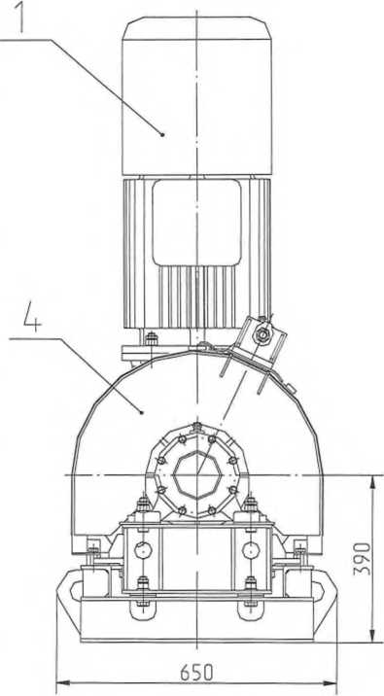
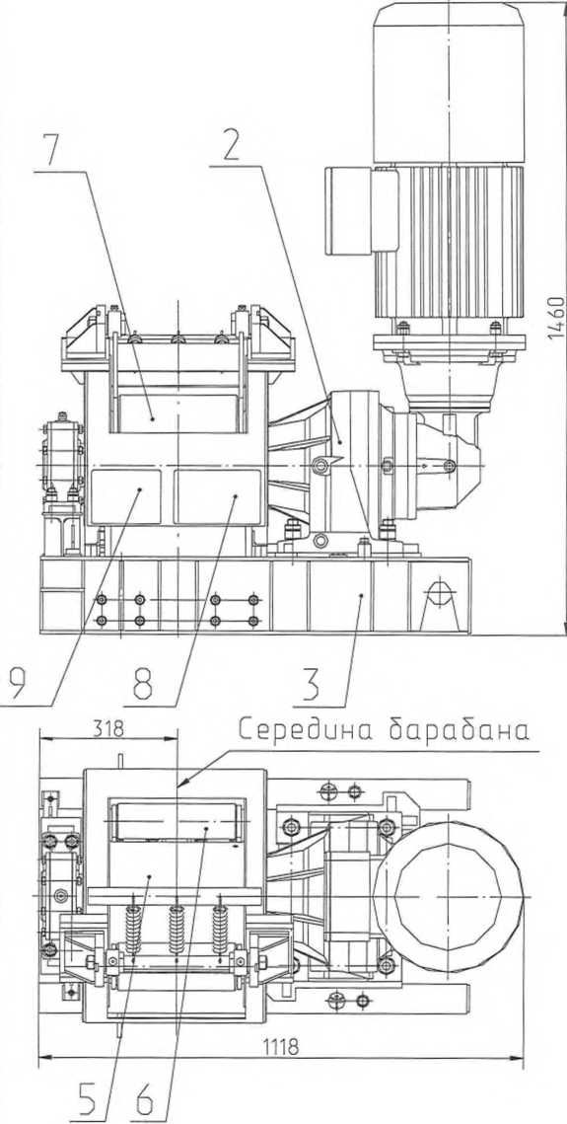
- - electric motor with brake;
Инв. № подл. Подл и дата Взам. инв.№ Инв. №дубл. Подл, и дата
- - angular planetary reducer, -
- - frame;
- - - fencing;
- - drum,-
- ,7 - pressure roller, -
8, 9 - plate;
Figure 1 - A possible design option for the auxiliary winch
 |  |  |  |  | 54024.44.000 ИТТ | Лист
 |  |  |  |  |  | 15
Изм | Лист | № докум. | Подп. | Дата

Figure 2 - Sketch of plates for installing a winch
Inv. no. |Signature and date I Subm. Inv. No. Inv. duplicate number Signed and date

Rope
Figure 3 - Scheme of rope reeving on the winch drum

aban lebabki

winch frame

Mobul frame winch
 |  |  |  |  | 54024.44.000 ITT | Sheet
 |  |  |  |  |  | 16
Izm | Sheet | Document No. | Signed | date

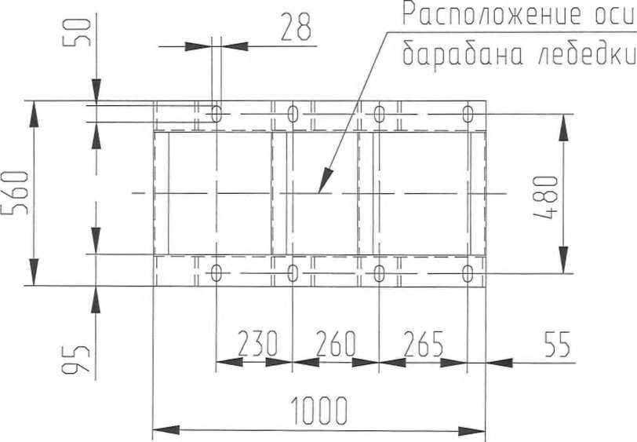
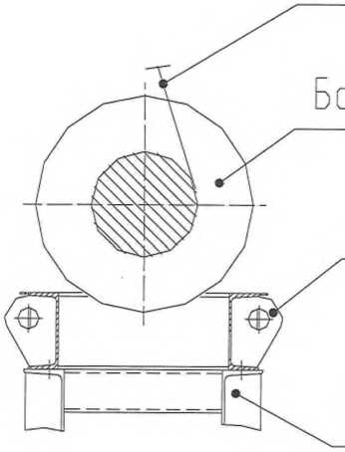

Change Registration Sheet
Change |  | Sheet (page) numbers |  |  |  |  |  |  | Total sheets (pages) in the document. | Document No. | Incoming No. of accompanying document and date | Signature | date
 |  | changed _ |  | replacement _ |  | new |  | canceled _ _
 |  |  |  |  |  |  |  | 54024.44.000 ITT |  |  |  |  |  | Sheet
 |  |  |  |  |  |  |  |  |  |  |  |  |  | 17
Izm | Sheet |  | Document No. |  | Signed |  | date

